Incoterms 2010 Take Effect January 1st, 2011

Sea and Inland Waterway Transport only
CFR Cost & Freight (named destination port)
Seller must pay the costs and freight to bring the goods to the port of destination.
However, risk is transferred to the buyer once the goods have
crossed the ship's rail. Maritime transport only and Insurance for the goods is
NOT included. Insurance is at the Cost of the Buyer.
CIF Cost, Insurance and Freight (named destination port)
Exactly the same as CFR except that the seller must in addition procure and
pay for insurance for the buyer. Maritime transport only.
FAS Free alongside ship (named loading port)
The seller must place the goods alongside the ship at the named port. The
seller must clear the goods for export. Suitable only for maritime transport
only but NOT for multimodal sea transport in containers (see Incoterms 2010,
ICC publication 715). This term is typically used for heavy-lift or bulk cargo.
FOB Free on board (named loading port)
The seller must themself load the goods on board the ship nominated by the
buyer, cost and risk being divided at ship's rail. The seller must clear the
goods for export. Maritime transport only but NOT for multimodal sea
transport in containers (see Incoterms 2010, ICC publication 715). The buyer
must instruct the seller the details of the vessel and port where the goods are
to be loaded, and there is no reference to, or provision for, the use of a
carrier or forwarder. It DOES NOT include Air transport. This term has been
greatly misused over the last three decades ever since Incoterms 1980
explained that FCA should be used for container shipments.
Any Mode of Transport
CIP Carriage and Insurance paid to (named place of destination)
The containerised transport/multimodal equivalent of CIF. Seller pays for
carriage and insurance to the named destination point, but risk passes when
the goods are handed over to the first carrier.
CPT Carriage paid to (named place of destination)
The general/containerised/multimodal equivalent of CFR. The seller pays for
carriage to the named point of destination, but risk passes when the goods
are handed over to the first carrier.
DAP Delivered at Place (named place)
Under DAP, delivery is when the seller puts the goods at the disposal of the
buyer at a named place, on a vehicle ready for unloading (that is, not
unloaded).
DAT Delivered at Terminal (named place)
delivery under DAT takes place when the seller puts the goods at the
disposal of the buyer unloaded at the named terminal.
DDP Delivered, Duty paid (named destination place)
This term means that the seller pays for all transportation costs and bears all
risk until the goods have been delivered and pays the duty. Also used
interchangeably with the term "Free Domicile". The most comprehensive term
for the buyer. In most of the importing countries, taxes such as (but not
limited to) VAT and excises should not be considered prepaid being handled
as a "refundable" tax. Therefore VAT and excises usually are not
representing a direct cost for the importer since they will be recovered
against the sales on the local (domestic) market.
EXW Ex Works (named place)
The seller makes the goods available at his premises. The buyer is
responsible for all charges. This trade term places the greatest responsibility
on the buyer and minimum obligations on the seller. The Ex Works term is
often used when making an initial quotation for the sale of goods without any
costs included. EXW means that a seller has the goods ready for collection at
his premises (Works, factory, warehouse, plant) on the date agreed upon.
The buyer pays all transportation costs and also bears the risks for bringing
the goods to their final destination.
FCA Free Carrier (named place)
The seller hands over the goods, cleared for export, into the custody of the
first carrier (named by the buyer) at the named place. This term is suitable for
all modes of transport, including carriage by air, rail, road, and containerised /
multi-modal sea transport. This is the correct "freight collect" term to use for
sea shipments in containers, whether LCL (less than container load) or FCL
(full container load).

Ocean Container Dimensions
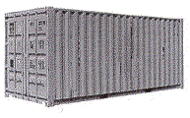 | STANDARD 20'
  INSIDE LENGTH  INSIDE WIDTH  INSIDE HEIGHT  DOOR WIDTH  DOOR HEIGHT  CAPACITY  TARE WEIGHT  MAX. CARGO | 19'4"  7'8"  7'10"  7'8"  7'6"  1,172 ft³  4,916 lb  47,999 lb | 5.89 m  2.33 m  2.38 m  2.33 m  2.28 m  33.18 m³  2,229 kg  21,727 kg

 |  | STANDARD 40' | HIGH CUBE 40'

INSIDE LENGTH  INSIDE WIDTH  INSIDE HEIGHT  DOOR WIDTH  DOOR HEIGHT  CAPACITY  TARE WEIGHT  MAX. CARGO |  | 39'5"  7'8"  7'10"  7'8"  7'6"  2,390 ft³  8,160 lb  59,040 lb | 12.01 m  2.33 m  2.38 m  2.33 m  2.28 m  67.67 m³  3,701 kg  26,780 kg |  | 39'5"  7'8"  8'10'  7'8"  8'5"  2,694 ft³  8,750 lb  58,450 lb | 12.01 m  2.33 m  2.69 m  2.33 m  2.56 m  76.28 m³  3,968 kg  26,512 kg

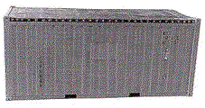
 |  | OPEN TOP 20'  (upgraded also available) | OPEN TOP 40'

INSIDE LENGTH  INSIDE WIDTH  INSIDE HEIGHT  DOOR WIDTH  DOOR HEIGHT  CAPACITY  TARE WEIGHT  MAX. CARGO |  | 19'4"  7'7"  7'8"  7'6"  7'2"  1,136 ft³  5,280 lb  47,620 lb | 5.89 m  2.31 m  2.33 m  2.28 m  2.18 m  32.16 m³  2,394 kg  21,600 kg |  | 39'5"  7'8"  7'8"  7'8"  7'5"  2,350 ft³  8,490 lb  58,710 lb | 12.01 m  2.33 m  2.33 m  2.33 m  2.26 m  66.54 m³  3,850 kg  26,630 kg

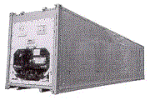
 |  | REEFER 20' | REEFER 40'

INSIDE LENGTH  INSIDE WIDTH  INSIDE HEIGHT  DOOR WIDTH  DOOR HEIGHT  CAPACITY  TARE WEIGHT  MAX. CARGO |  | 17'8"  7'5"  7'5"  7'5"  7'3"  1,000 ft³  7,040 lb  45,760 lb | 5.38 m  2.26 m  2.26 m  2.26 m  2.20 m  28.31 m³  3,193 kg  20,756 kg |  | 37'8"  7'5"  7'2"  7'5"  7'0"  2,040 ft³  10,780 lb  56,276 lb | 11.48 m  2.26 m  2.18 m  2.26 m  2.13 m  57.76 m³  4,889 kg  25,526 kg

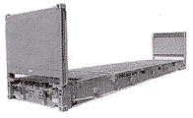
 |  | FLAT RACK 20' | FLAT RACK 40'

INSIDE LENGTH  INSIDE WIDTH  INSIDE HEIGHT  TARE WEIGHT  MAX. CARGO |  | 18'5"  7'3"  7'4"  5,578 lb  47,333 lb | 5.61 m  2.20 m  2.23 m  2,530 kg  21,469 kg |  | 39'7"  6'10"  6'5"  12,081 lb  85,800 lb | 12.06 m  2.08 m  1.95 m  5,479 kg  38,918 kg

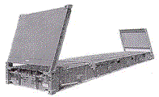
 |  | FLAT RACK COLLAPSIBLE 20' | FLAT RACK COLLAPSIBLE 40'

INSIDE LENGTH  INSIDE WIDTH  INSIDE HEIGHT  TARE WEIGHT  MAX. CARGO |  | 18'6"  7'3"  7'4"  6,061 lb  61,117 lb | 5.63 m  2.20 m  2.23 m  2,749 kg  27,722 kg |  | 39'7"  6'10"  6'5"  12,787 lb  85,800 lb | 12.06 m  2.08 m  1.95 m  5,800 kg  38,918 kg

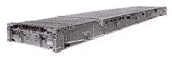
 |  | PLATFORM 20' | PLATFORM 40'

INSIDE LENGTH  INSIDE WIDTH  INSIDE HEIGHT  TARE WEIGHT  MAX. CARGO |  | 19'11"  8'0"  7'4"  6,061 lb  52,896 lb | 6.07 m  2.43 m  2.23 m  2,749 kg  23,993 kg |  | 40'0"  8'0"  6'5"  12,783 lb  66,397 lb | 12.19 m  2.43 m  1.95 m  5,798 kg  30,117 kg

Air Container Dimensions
Main Deck Pallet  (Equivalent to IATA Type 2)  External Displacement:  606 cu ft/17.16 cu m  Maximum Gross Weight:  15,000 lb/6,804 kg  Maximum External Dimensions:  (L x W x H) Contoured  125" x 96" x 96"  317cm x 244cm x 244cm | 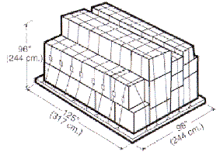
LD-7  (Equivalent to IATA Type 5)  External Displacement:  379.9 cu ft/10 cu m  Maximum Gross Weight:  10,200 lb/4,627 kg  Maximum External Dimensions:  (L x W x H) Contoured  125" x 88" x 63"  317 cm x 223 cm x 160 cm | 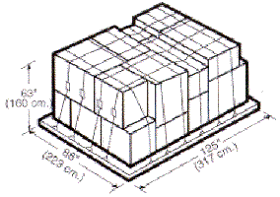
P9A Lower Deck Pallet  (Equivalent to IATA Type 6)  External Displacement:  242 cu ft/6.9 cu m  Maximum Gross Weight:  7,000 lb/3,175 kg  Maximum External Dimensions:  (L x W x H) Contoured  125" x 60" x 63"  317 cm x 152 cm x 160 cm | 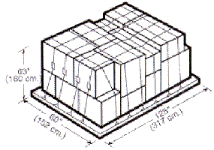
LD-11  (Equivalent to IATA Type 6)  Internal Capacity:  242 cu ft/6.9 cu m  Maximum Gross Weight:  7,000 lbs/3,176 kg  Maximum External Dimensions:  (L x W x H) Contoured  125" x 60" x 64"  317 cm x 162 cm x 162 cm | 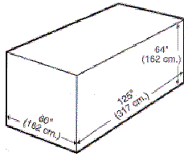
LD-8  (Equivalent to IATA Type 6A)  Internal Capacity:  243 cu ft/6.9 cu m  Maximum Gross Weight:  5,400 lb/2,450 kg  Maximum External Dimensions:  (L x W x H) Contoured  96" x 60" x 64"  228 cm x 152 cm x 162 cm | 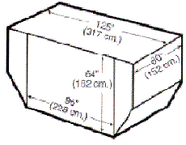
LD-4  (Equivalent to IATA Type 7A)  Internal Capacity:  174 cu ft/5 cu m  Maximum Gross Weight:  5,400 lb/2,450 kg  Maximum External Dimensions:  (L x W x H) Contoured  96" x 60" x 64"  228 cm x 152 cm x 162 cm | 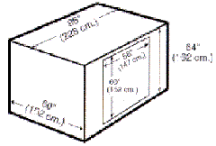
LD-3  (Equivalent to IATA Type 8)  Internal Capacity:  150 cu ft/4 cu m  Maximum Gross Weight:  3,500 lb/1,588 kg  Maximum External Dimensions:  (L x W x H) Contoured  61" x 60" x 64"  154 cm x 152 cm x 162 cm | 